7-1 Final Project – Design Decisions

Cristiano Miranda
Southern New Hampshire University
CS-330: Comp Graphic and Visualization
Professor Gerlach
19 April 2026

7-1 Final Project – Design Decisions
The 3D scene I created was a replica of an image of my soldering workbench. On this workbench were my soldering iron and station, a screwdriver, a wrench, a fan, a set of drawers, a plastic bin, and, finally, a soldering mat. The main reason for choosing these objects was their complexity, as they would require multiple shapes to properly recreate, allowing me to effectively learn how to manipulate and handle shapes to recreate real-world objects. These objects, while complex, could be recreated using the provided shapes as a base. While other objects would have been appropriate to the scene, like smaller storage boxes or soldering spools, these kinds of items would have been redundant and would have been simple shapes rather than complex ones. Using complex objects gave the chance to work with different shapes, provided a better learning experience, and allowed nearly all types of shapes to be combined to match a real-world object as closely as possible. Other development choices made during the creation of this 3D rendering included adding water to the plastic bin to better denote what it was. While all other objects in the scene could be understood through simple observation, the slightly opaque bin was the exception, as viewing it did not fully convey what it was meant to be. Having the slightly opaque boxes form a bin would have failed to fully convey what the object was and could have left viewers unsure of how this bin fits into the scene. Thus, adding water to the bin allows viewers to better understand the object's purpose and, in turn, comprehend what it is. Also, this inclusion better highlights the lighting in the scene by introducing a larger reflective surface, as most other reflective surfaces are not large enough to show how the lighting affects more reflective materials properly. Finally, the last major design decision was to exclude cords from the rendering, as they would have cluttered the scene. While adding them would have made the scene as true to life as possible, this also would have caused the main focal points of the project, the recreation of the 3D objects, to be obscured in favor of the wires. Additionally, the scene captures only the top of the workbench, and many of the plugs and wiring run under it, so including the wires would have had them running off the table into an empty area, drawing attention to areas that were not recreated. Thus, the decision not to include wires allowed the scene to be less cluttered and to place more emphasis on its main elements. In the end, careful consideration was placed into all design choices along with the objects that appeared within the scene, and other choices such as the addition of water and the exclusion of wires were made for the sake of allowing the objects in the scene to be more easily visible and better expressed and understood by all viewers.
Navigation is essential in 3D rendering to properly observe all potential views of the objects and see how they can be observed differently depending on the angle, position, and orientation of the camera. To accomplish this, specific keys are assigned to control specific camera movements. The main camera controls include the W, A, S, and D keys, which move the camera forward, left, right, and backward, respectively. The Q and E keys adjust the camera height by raising or lowering it. Additionally, the camera can be moved without changing its position by moving the mouse cursor, which will move the camera's view within the scene. The mouse's scroll wheel also controls the camera's speed: scrolling up decreases the movement speed, and scrolling down increases it. The camera view can also switch from a 2D orthographic view by pressing the O key to a 3D perspective view via the press of the P key. The last controls for the scene include the 1, 2, and 3 keys, which control the lighting and allows it to be set to different presets. As the site Womp mentions in its article, lighting has a major effect in a 3D scene, as it "plays a vital role in enhancing realism, evoking emotions, and guiding the viewer's attention" (Illuminate Your 3D Projects: Understand the Art of Using Lighting in 3D Rendering, 2025). To allow the viewer to see the scene with different light sources, the keys were assigned to different light-source presets, enabling the user to adjust specific light-source values to view the scene in different ways. The 1 key sets the lighting to a softer, non-harsh tone that illuminates the scene without harsh highlights and provides a neutral color balance. The 2 key is the scene's default lighting, which matches the original image as closely as possible by slightly increasing the light's hue to match the lighting for my real-world soldering workbench, and this also increases the light's intensity. The final preset, bound to the 3 key, is a sharper lighting preset that further increases the color hue from the default lighting, providing a more yellow tint to the scene to match the sun around dawn, which is the main time it hits my soldering workstation. This preset increases the light intensity to provide harsher lighting, similar to sunlight, allowing the scene to be viewed in brighter conditions. In the end, camera navigation allows the camera and view to move and change, enabling different ways to observe the scene and view how different lighting conditions affect it.
Navigation within the scene is possible, allowing viewers to observe it from different perspectives. To accomplish this, a dedicated ViewManager class was created that manages a keyboard callback method that handles keyboard interactions by triggering methods based on specific keys. These specified keys, detailed in the console upon launching the project, manipulate the camera, view, and scene in different ways. 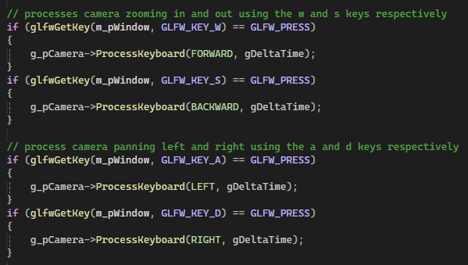
Figure 1 - Code example of how the window checks what key is pressed and performs the appropriate action.
The figure above demonstrates how the keyboard event checker triggers a specific action corresponding to the key being pressed. In this case, pressing any movement key calls the camera object's ProcessKeyboard() method, which, in turn, adjusts the camera accordingly. The event pattern continues when pressing the other keys for the project. Still, in cases like the 1, 2, 3 keys, which alter the lighting preset for the scene, instead of manipulating the camera, it alters a different object, the interaction manager object, to affect the scene as opposed to the camera. 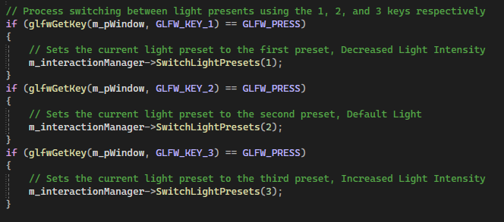
Figure 2 - Code example of how the 1, 2, and 3 keys trigger differnet methods to alter the scene as opposed to the camera.
While the same method used to check key press events on the window still applies in this situation, the outcome differs because a different side effect occurs for these keys. Instead of affecting the camera, it changes the scene, so a different object is used, and its methods are triggered instead. The same principles apply: the window is checked for key press events, and when they occur, a reaction occurs. As with key press events, a similar check is used to observe the user's mouse so it can control specific elements of the scene. However, instead of having a keyboard callback in which certain keys trigger specific actions, callbacks for both the mouse wheel and mouse cursor movements are used.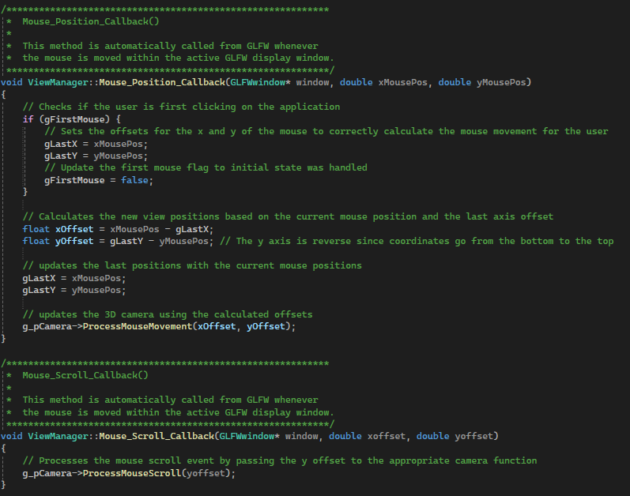
Figure 3 - Code example of the user’s cursor is set relative to the window’s view port so that any cursor movement moves the current view in the scene.
As shown above, rather than having events that wait for a keypress, these methods are focused on the user's mouse and trigger reactions when the user moves the cursor or scrolls the scroll wheel. When the mouse cursor moves, this triggers the method to recalculate how the view would be affected by the cursor's movement, and then calls the camera object's method to rerender the camera view. For the mouse scroll, the same event is used to check the window and determine when the user scrolls, and it passes the amount scrolled to the camera object's method, which in turn adjusts the scene's movement speed. Still, all user actions within the project create events that observe the user's interaction with the project window. When specific user interactions occur, the appropriate reaction is triggered; for example, when a user presses the W key, the camera moves forward, or when the mouse cursor moves, the camera view moves with it. All these features enable the user to move around the camera and view and adjust the scene.
The project has numerous objects, and the number of basic shapes needed to recreate them is even greater. To reduce dry code in the project, custom functions, classes, and header files were created to reduce the required code and enable the addition of certain features. The main functions added to the project were the DrawShape() and TransformShape() methods within the SceneManager class. These methods removed the need to reenter the necessary methods to draw, manipulate, and transform shapes, and instead allow a single method to call the DrawShape() method, since it houses all of these methods into a singular function, so that only a single method call is needed to render a shape to the 3D scene. In this method, the TransformShape() method handles rotation, translation, and scaling of the shape, then returns to the DrawShape() method, which finishes by drawing the shape to the scene after applying shaders. Instead of having to write the same code for each shape or even call the different methods, only a single call to the DrawShape() method is needed. For this method to be effective, it requires all shape data to be provided for it to be drawn, and to ease this process, a new object structure, labeled ObjectData, was created to house all shape data information that needs to be passed to the method so that it can be rendered in the 3D scene. Using these methods made drawing each shape in the scene much easier by greatly reducing the amount of repeated code and enabling loops to call the method for every shape within an object repeatedly. Creating this method not only improves the code's readability in this project but can also be easily reused in other projects to ease the creation of objects and shapes for 3D renderings. Even with this addition and its ease of reuse, it was necessary to add a new class, the SceneObjects class, to house all information about the scene's objects and their individual shape data, reducing the total code in the SceneManager class to improve readability. Adding this class removed the need to store shape data within the SceneManager and instead encapsulated it in a single place. The SceneManager class now instantiates a new SceneObjects class upon loading. It uses the defined methods to gather all shapes for each object into a vector. With this shape data, a for loop can be used to easily call the DrawShape() methods, significantly reducing the code needed to render a single object. While this took some time to create and required multiple rewrites to add new features, it was well worth it. This change reduced the complexity of the SceneManager class, uncluttered its Render() method, and made it far easier to understand and work with. Additionally, it allowed for a class that houses separate methods for each object, making management easier since all information is in a single, easier-to-find area. The other benefit of encapsulating all object shape data into a separate class is the ability to reuse these objects in other projects, as instead of having to copy all shapes data and rerender it in other project, simply adding the class to the new project and calling the same method to gather object data would result in the same object being rendered in the new project.
One major change to this project was the inclusion of an InteractionManager class, which is instantiated before all other objects in the MainCode class and passed to the ViewManager and SceneManager classes. This new class utilizes the other two classes to view user input within the ViewManager class and to trigger changes in the 3D scene via the SceneManager class. This InteractionManager class created a bridge that allowed the ViewManager and SceneManager classes to use features of both by housing different lighting source values for the scene and providing methods to change the current light source values. Passing this class to the ViewManager allows it to assign specific keyboard keys to methods in the InteractionManager class that change the current lighting source class pointer. 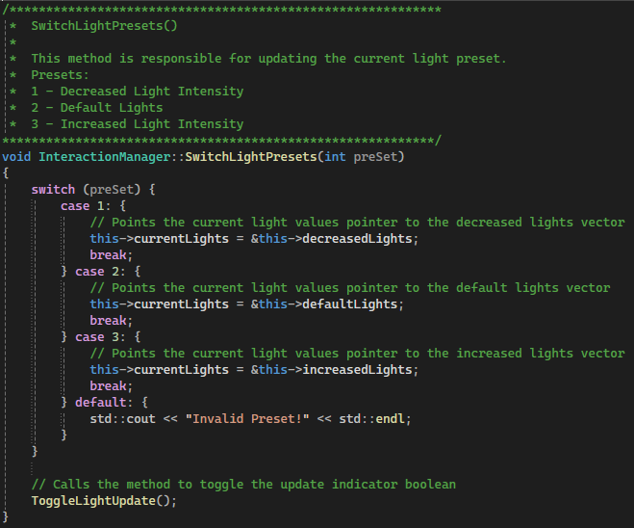
Figure 4 – A switch case is used to change the pointer for the current light source to quickly switch between the current light source values for the scene, and the light update Boolean is changed when the present changes.
The above code shows how lighting sources are changed: rather than instantiating a new vector every time, a pointer points to the current light source for the scene, reducing the complexity of the switching action. Additionally, a Boolean is used to indicate when an update has occurred, allowing the SceneManager's Render() method to know when to update the light sources and avoid constantly rerendering them when the values have not changed. While there is an initial light source setup function, a different method, UpdateSceneLights(), is used to update the scene's light source values based on the user's selected preset, allowing different error handling for both light source setup and changes. Still, this requirement was unintentional, as the original goal was to combine the setup and update methods to reduce the project's code. However, the differences between the setup and updating of the lights made it necessary to split these functions. Even with this difficulty, the change still improved the code by allowing the addition of a for loop to set up or update scene lights, rather than having to define each separate light and its values within the SetUpSceneLights() method. Instead, the scene light values are now stored in the InteractionManager class, within a single object that uses a custom object structure, called LightSourceVals, to store all light information. To access these objects and the vector that stores them, a getter method retrieves the scene lighting values from the vector. Again, this enables a for loop to iterate over the vector, assigning the expected values to the four light sources in the scene without having to separately write each light source and its values. Overall, while this addition focused mainly on adding a custom feature and required an additional function to operate, it also simplified the original action of initializing all light sources in the scene and made editing light source values much simpler.
References
Illuminate your 3D projects: Understand the art of using lighting in 3D Rendering. (2025).
Womp.com. https://www.womp.com/blogs/illuminate-your-3d-projects-understand-the-art-of-using-lighting-in-3d-rendering

